Sanad ســــــــــند

**Introduction:**

There are two types of work, traditional work, and freelancing or work from home, the concept of freelancing is developed in 2010 and it has become one of the most requested fields these days.

Nowadays, most people in Egypt and other countries work with freelancing, and the Egypt government support the freelancers with awesome initiatives like The Future of Digital Egypt (**[EgyptFWD](https://egfwd.com/)**), Digital Egypt Builders, and other initiatives by Ministry of Communications and Information Technology.

50% of people in Europe and America became working from home and freelancing to make things easier for people, and more than 767,000 Egyptian works in freelance.com according to website statistics, This field helps clients find what they want easily and give them outlet to easily contact with providers.

And with the spread of the Corona pandemic and the great closure, and many people lost their jobs, which included all government and service sectors, the biggest trend was to freelancing.

**Types of Freelancing:**

We have 3 kinds of freelancing:

1. **Service freelancing:** user(provider) offers his service, then people come to ask him,

* Example of this type: “Fiverr.com”.

1. **Project Freelancing:** businessman put their project (what they want), then freelancers offer to serve them.

* Example of this type: “Upwork.com”

1. **Work Remotely:** Employee Work From Home.

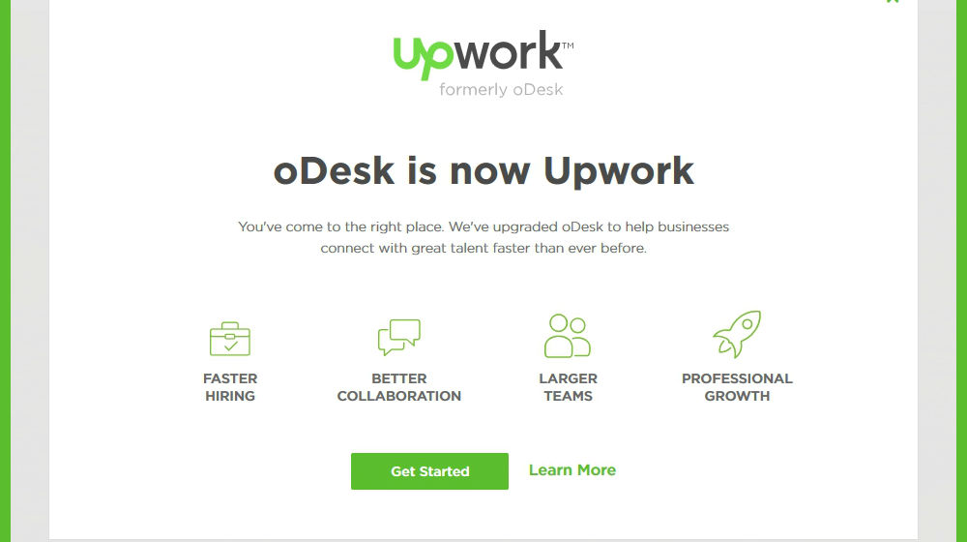

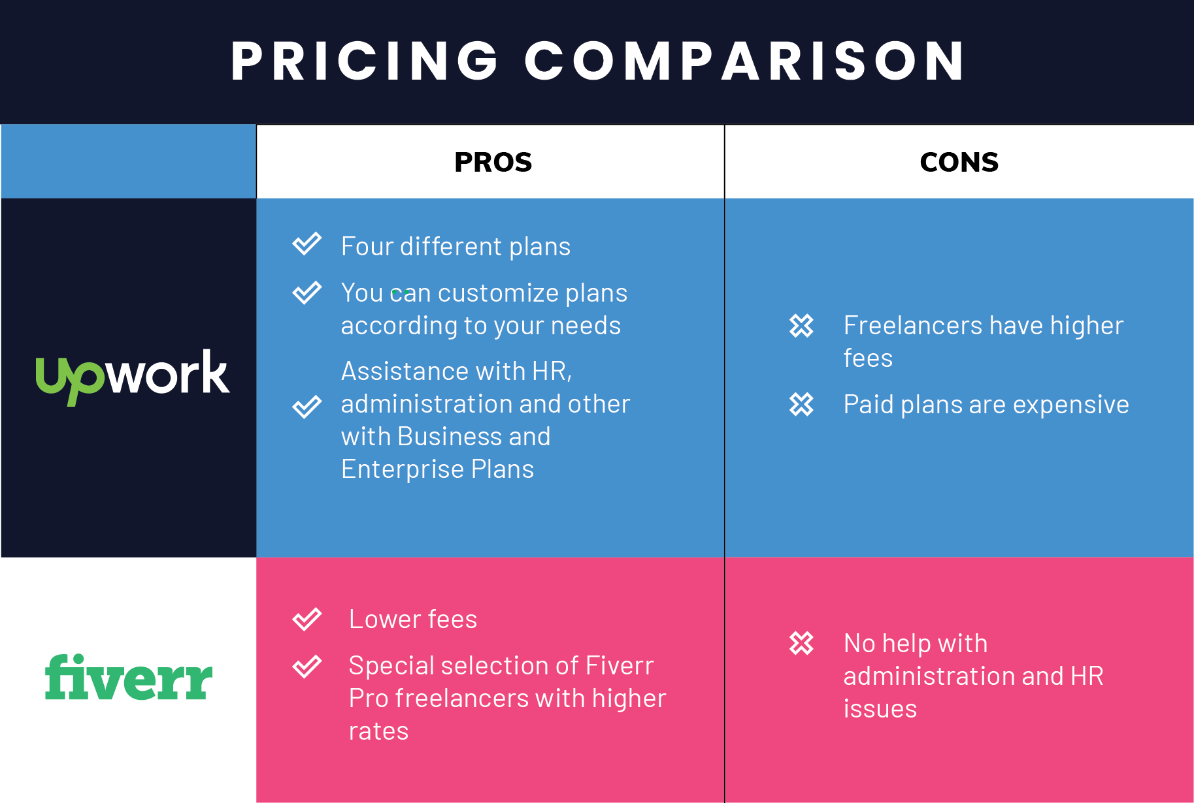

**Sanad:**

**Sanad** **سنــد** is a Arabic freelancing website that is combination of Upwork and Fiverr, it’s support Arabic freelancer and businessman to complete their works with fair price in fast way.

Features:

* Add Service Functions (CRUD).
* Add Project Functions (CRUD).
* Approved / Declined Service and Project (by Admin).
* Create Customer Support System.
* Create Email System.
* Create Marketing System.
* Create Payment System
* Add Traditional Payment Method
* We will use payment methods more secure (Crypto Currency).
* Reduce Fees (Both Developer & Client)
* Freelancers gets notifications (email) when any person ask for service which he is offer, User (customer) get notifications (email) when new provider sign in website and offer service, he wants.
* Website will accept freelancers (17+ years) to offer his service.